Step 1: Top left corner, click on settings (see image here):
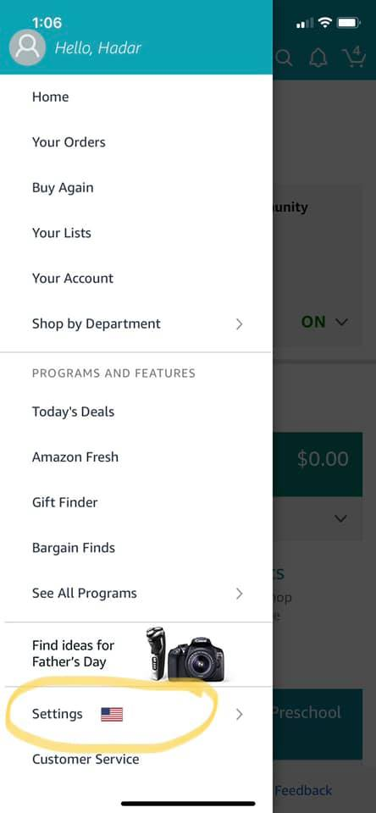

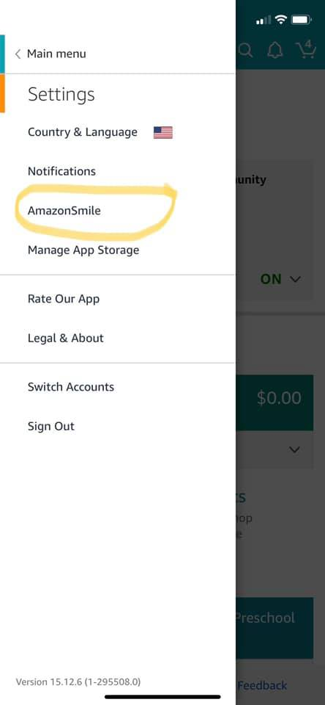
Step 2: Click on Amazon Smile, click “ON” to turn on this function for when you shop Amazon on your phone (see image here):

